Data Structure and Algorithm
Laboratory Activity No. 13

Tree Algorithm

Submitted by: | Instructor:
Nerio, Hannah Grace A. | Engr. Maria Rizette H. Sayo

November 06, 2025

Objectives
Introduction
An abstract non-linear data type with a hierarchy-based structure is a tree. It is made up of links connecting nodes (where the data is kept). The root node of a tree data structure is where all other nodes and subtrees are connected to the root.

This laboratory activity aims to implement the principles and techniques in:
- To introduce Tree as Non-linear data structure
- To implement pre-order, in-order, and post-order of a binary tree
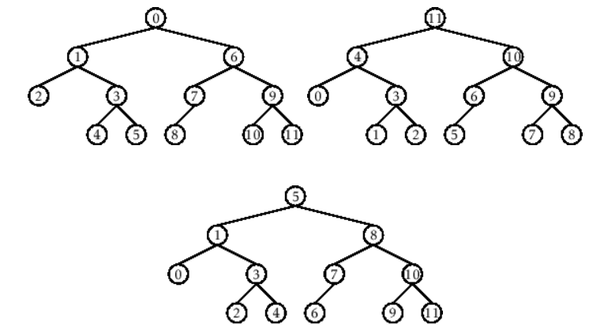

- Figure 1. Pre-order, In-order, and Post-order numberings of a binary tree

Methods
  - Copy and run the Python source codes.
  - If there is an algorithm error/s, debug the source codes.
  - Save these source codes to your GitHub.
  - Show the output

    - Tree Implementation

class TreeNode:
def __init__(self, value):
self.value = value
self.children = []

def add_child(self, child_node):
self.children.append(child_node)

def remove_child(self, child_node):
self.children = [child for child in self.children if child != child_node]

def traverse(self):
nodes = [self]
while nodes:
current_node = nodes.pop()
print(current_node.value)
nodes.extend(current_node.children)

def __str__(self, level=0):
ret = " " * level + str(self.value) + "\n"
for child in self.children:
ret += child.__str__(level + 1)
return ret

# Create a tree
root = TreeNode("Root")
child1 = TreeNode("Child 1")
child2 = TreeNode("Child 2")
grandchild1 = TreeNode("Grandchild 1")
grandchild2 = TreeNode("Grandchild 2")

root.add_child(child1)
root.add_child(child2)
child1.add_child(grandchild1)
child2.add_child(grandchild2)

print("Tree structure:")
print(root)

print("\nTraversal:")
root.traverse()

Questions:
- When would you prefer DFS over BFS and vice versa?
- What is the space complexity difference between DFS and BFS?
- How does the traversal order differ between DFS and BFS?
- When does DFS recursive fail compared to DFS iterative?

Results
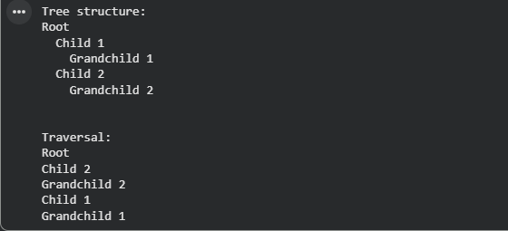

Figure 1 Screenshot of the output
Questions:
    - When would you prefer DFS over BFS and vice versa?
You would prefer DFS (Depth-First Search) over BFS (Breadth-First Search) when you're dealing with problems where you want to explore as far as possible down a single branch before backtracking, such as in tasks like pathfinding, topological sorting, or when solving puzzles (e.g., mazes). DFS is particularly useful when the tree or graph is deep, and memory usage is a concern because it only stores the current path and its children, not all nodes at a given level. On the other hand, BFS is better when you're searching for the shortest path in an unweighted graph, as it explores all nodes level by level and guarantees that the first time a node is visited, it is via the shortest path. BFS is also useful in applications like level-order traversal or when the structure is wide (e.g., in network broadcasting). However, BFS can be more memory-intensive compared to DFS because it needs to store all nodes at each level before moving deeper.

    - What is the space complexity difference between DFS and BFS?
The space complexity of DFS (Depth-First Search) is O(h), where h is the height of the tree or graph. This is because DFS only needs to store the nodes along the current path, which means it requires space proportional to the maximum depth it reaches. In the worst case, for a very deep but narrow tree, DFS will require space proportional to the tree's height. On the other hand, the space complexity of BFS (Breadth-First Search) is O(w), where w is the maximum width of the tree or graph. This is because BFS needs to store all the nodes at the current level in a queue before moving to the next level. In graphs or trees with high branching factors, BFS can require significantly more space than DFS, since it needs to store many nodes at once.

    - How does the traversal order differ between DFS and BFS?
In DFS (Depth-First Search), the traversal starts at the root node and proceeds as deeply as possible down each branch before backtracking. It uses a stack (either implicit via recursion or explicit) to track nodes. For example, in a tree structure, DFS will explore a child node completely before moving to its sibling node. The order in which nodes are visited follows a deep path first, visiting a node’s descendants before its neighbors. In BFS (Breadth-First Search), the traversal starts at the root node and explores all nodes at the current level (or depth) before moving on to the next level. It uses a queue to manage the nodes to be visited next. This ensures that all nodes at level 1 are visited before moving to level 2, and so on. BFS processes nodes in layers, visiting a node’s neighbors before moving deeper.
    - When does DFS recursive fail compared to DFS iterative?
Recursive DFS can fail when the graph or tree is particularly deep, causing a stack overflow. This happens because every recursive call adds a new frame to the system's call stack. If the recursion goes too deep—such as in a very large or deep tree or graph—this can exhaust the available stack space and result in an overflow error. Deep recursion in a large dataset can thus cause the program to crash or behave unexpectedly, especially in environments with limited stack memory. In such cases, an iterative DFS implementation, which uses an explicit stack, can avoid this issue since it does not rely on the system’s call stack and is less likely to run into stack overflow problems.

Conclusion
This laboratory activity provided a clear and practical introduction to tree data structures, which are essential for organizing data in a non-linear, hierarchical manner. By understanding how trees are built with nodes and links, and with the root node as the foundation, we gained a solid grasp of the structure and functionality of trees. This lab focused on implementing three fundamental tree traversal techniques—pre-order, in-order, and post-order—which allowed us to explore different ways of visiting nodes in a tree. Each traversal method serves a specific purpose and is useful in various applications, such as searching, sorting, and data manipulation.
By working through these implementations, we not only learned how to navigate trees efficiently but also saw the importance of trees in solving real-world problems, from file management systems to more complex algorithms. This hands-on experience reinforced the theoretical concepts behind tree structures and traversal methods, showing their significance in computer science. Ultimately, this activity helped strengthen our understanding of trees as a powerful tool for organizing and accessing data and highlighted their practical applications in problem-solving across a variety of fields.

References
[1] Co Arthur O.. “University of Caloocan City Computer Engineering Department Honor Code,” UCC-CpE Departmental Policies, 2020.
[2] GeeksforGeeks, “Difference between BFS and DFS,” GeeksforGeeks, Nov. 01, 2025. https://www.geeksforgeeks.org/dsa/difference-between-bfs-and-dfs/
[3] “Amazon.com: Data Structures & Algorithm Analysis in C++: 9780132847377: Weiss, Mark: Books.” https://www.amazon.com/Data-Structures-Algorithm-Analysis-C/dp/013284737X

